Echo Lake Bible Camp

Renters Handbook

Updated: Apr. 24, 2012

Echo Lake Bible Camp Page 1

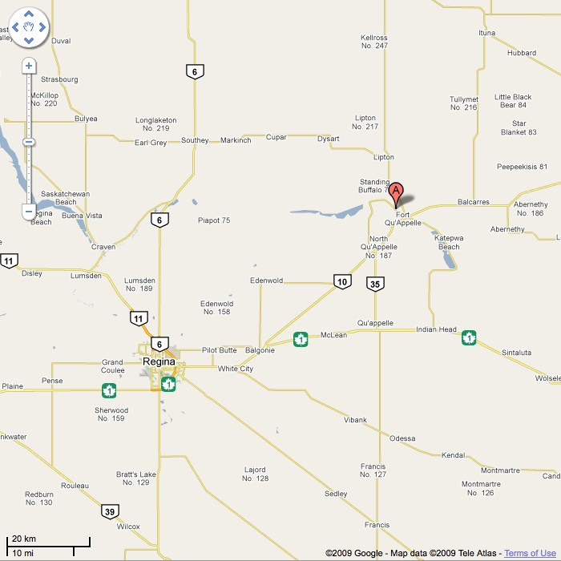

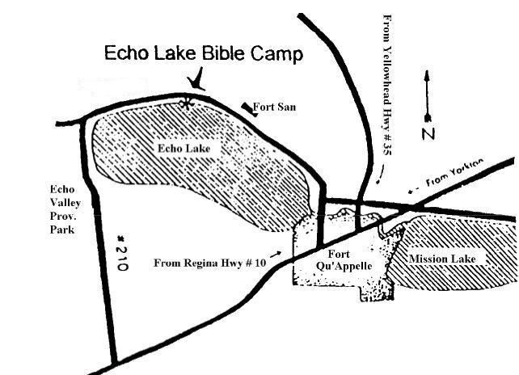

INTRODUCTION

Echo Lake Bible Camp is nestled in a wooded area on the north shore of scenic Echo Lake, 3 miles N.W. of Fort Qu'Appelle, Saskatchewan, along Highway #56. It is situated on 10 acres of prime lakefront property, allowing access to numerous waterfront activities.
Since 1933 the camp has been owned and operated by the Evangelical Missionary Church of Canada. While priority is given to the denominational camping and conference programs, on the basis of availability, the facility can be used by other Christian groups who desire to use it, primarily for the purpose of Christian camping,
On occasion, it is used by local churches as a seminar and training center, or by families for such gatherings as family reunions, anniversaries, etc. The main jubilee building is available for use all year round.

Echo Lake Bible Camp is sponsored by and under the direction of the Evangelical Missionary Church with its head administrative office at:
EVANGELICAL MISSIONARY CHURCH OF CANADA
West District Office
4031 Brentwood Rd. N.W. Calgary, Alberta T2L 1L1

The camp is operated and managed by a board of director’s elected from members of the camp. The camp has a full time camp manager who looks after the on going operations of the camp and is happy to host and assist persons who use the site.
I encourage you to acquaint yourself with the information that follows. It was prepared to assist you in your plans to retreat and relax at Echo Lake Bible Camp.

THE PURPOSE OF CHURCH CAMPING

The overall Statement of Purpose for our Camping ministry is:

“To provide a rewarding camp experience for people of all ages. A Christ centered program seeks to nurture spiritual, physical and social development, which will benefit the larger social community.”

Laura Funk On Site Manager
Box 593 Chris Strachan Phone (306) 332-4443 Phone (306) 537-4302
Dalmeny, SK S0K 1E0 manager@elbc.co
elbctreasurer@gmail.com

RENTAL AGREEMENT

The regulations and responsibilities outlined here are established to provide a wholesome atmosphere for social, emotional, intellectual and spiritual development. It is also our purpose to protect the integrity and standards of Christian Camping for future generations of campers, therefore, we must remain true to our Statement of Faith, our interpretation of the Holy Bible, and Echo Lake Bible Camp’s Code of Conduct.
While on our property, we require all individuals, rental groups, campers, visitors, and staff to respect our Statement of Faith and our Code of Conduct. By signing the rental agreement, the rental contact person assumes all responsibility to convey the following Statement of Faith and Code of Conduct with those he/she is representing on behalf of the group. It is also agreed that the rental group will abide by the Code of Conduct and will not teach, promote, or practice anything that is in opposition to or is inconsistent with our Statement of Faith while on any Echo Lake Bible Camp owned or operated property. We wish you a most pleasant, refreshing and enjoyable experience.

STATEMENTS OF FAITH AND CHRISTIAN CONDUCT FOR ECHO LAKE BIBLE CAMP

The Statement of Faith* of ELBC is as follows:
- THE HOLY SCRIPTURES as originally given by God, divinely inspired, infallible, entirely trustworthy; and the only supreme authority in all matters of faith and conduct.

- ONE GOD, eternally existent in three Persons, Father, Son and Holy Spirit.

- OUR LORD JESUS CHRIST, God manifest in the flesh, His virgin birth, His sinless human life, His divine miracles, His bodily resurrection, His ascension, His mediatorial work, and His personal return in power and glory.

- THE SALVATION of the lost and sinful people through the shed blood of the Lord Jesus Christ by faith apart from works, and regeneration by the Holy Spirit.

- THE HOLY SPIRIT by whose indwelling the believer is enabled to live a holy life to witness and work for the Lord Jesus Christ.

- THE UNITY in the Spirit of all true believers, the Body of Christ, visibly expressed in the cooperative life of believers in congregations and in kingdom enterprise.

- THE RESURRECTION of both the saved and the lost; they that are saved unto the resurrection of life, and they that are lost unto the resurrection of damnation.

* THESE ARTICLES are the non-negotiable Essentials of the Christian faith. The statement is Orthodox and Evangelical.
Orthodox means in agreement with the historic teaching of the Christian faith as expressed in the historic creeds. Evangelical means an emphasis on the Biblical gospel about salvation by faith in Christ and new life (regeneration) by the transforming work of the Holy Spirit. This new life is essential to the Christian walk.

The Statement of Christian Conduct of ELBC is as follows:

- The Christian’s conduct is modeled on the example of Jesus.

- Out of gratitude to God for His Covenant love, empowered by the Spirit of Holiness, informed and shaped by the instruction of the Word of God, the Christian walks in the steps of Jesus, obedient to the teaching of Jesus.

- The Scriptures teach that the divine pattern for marriage is the union of one man and one woman in a lifelong covenant relationship in mutual submission to Christ where care and respect for each other are practiced.

- The Scriptures teach that the believer is to be unfettered by anything that attains an addictive, compulsive or idolatrous dominance or control in one’s life and conduct.

- The Scriptures teach that the believer is to walk above reproach in the world; to be just in one’s dealing and faithful in one’s engagements.

Code of Conduct
We have designed a Code of Conduct that we require all individuals, renters, groups, and visitors to follow and adhere to. While on Echo Lake Bible Camp owned or operated property, the group agrees to refrain from the following:
- Practicing, teaching, and/or promoting any religious practices contrary to or not in accordance with the Statement of Faith of Echo Lake Bible Camp
- Teaching, promoting or engaging in all unbiblical relationships
- Teaching, promoting or engaging in practices that contradict Echo Lake Bible Camp’s belief that marriage is only between one man and one woman as it is described in the Holy Bible
- Reading, viewing, or possessing pornographic material
- Consumption or possession of alcoholic beverages
- Use of profane or blasphemous language • Smoking in any buildings or on the grounds.
- Littering, destruction of wildlife and/or nature, or hunting • Allowing pets on any camp premises.
- Engaging in any behavior contrary to the Criminal Code of Canada
- No speeding with vehicles
- No excessive noise after 11:00 PM

Participating in any one or more of the above listed points will render the individual, renter, and/or group in breach of Echo Lake Bible Camp’s Code of Conduct. Consequences and actions due to a breach of the Code of Conduct will be at the discretion of Echo Lake Bible Camp staff and will be based on the degree of undue hardship the breach has or may cause Echo Lake Bible Camp. Actions may include, but not be limited to, an individual and/or group being asked to leave the grounds and pay for all damages related to their actions and be required to fulfill all financial obligations even if their stay is cut short due to a breach of our Code of Conduct.

Facilities
- Rental fees entitle you to use buildings necessary for your program. Information on the location and capacities of all buildings is enclosed. Determine your requirements and provide the Camp Manager with the information at least one week prior to your arrival.
- The use of the kitchen and dining room are included in the rental fee, each rental group is responsible for their own food services.
- Food Supplies - Dish washing - Cooks and kitchen help - Care of the dining facilities • Salt, pepper, plates, bowls, cutlery and paper napkins are included.

. Supplies
• All janitorial supplies, sanitation paper products and products required for the operation and maintenance of the automatic dishwasher will be provided.

Supervision
- It is recommended that all groups have:
  - An adult Director or Program Coordinator
  - A Nurse or person responsible for administering aid
  - A lifeguard and/or qualified water safety personnel
- Youth and children's groups should have an adult leader or chaperone on the ratio of 1 for every 10 campers.
- No camp program or activity shall contravene Christian moral and ethical principles.

Damage or Destruction of Property
• Groups renting the facilities of Echo Lake Bible Camp shall provide a security deposit fee of $300 prior to assuming occupancy of the camp facilities. Each group is responsible for damage, beyond normal wear and tear, to camp buildings, equipment and grounds in general. The Camp Manager shall assess any such damage prior to the conclusion of your camp and consult the rental group's program director. The rental organization will then be invoiced accordingly. The security deposit, or a portion thereof, shall first be applied against any claim for damages.

Rates
• Echo Lake Bible Camp reserves the right to revise rates as necessary, with notice of rate changes to be given by November 15th of the year prior to year in which the changes become effective.

Insurance
- Rental groups must Purchase and maintain public liability insurance of not less than $2,000,000.00 and insurance on equipment and contents. A certificate of liability must be received with the signed contract. You must include Evangelical Missionary Church of Canada as an additional insured with respect to the proposed occupancy.
- While every precaution is taken for the safety and good health of the members of the group that is on site, the rental applicant’s signature on the rental application releases Echo Lake Bible Camp, and it’s directors, staff, and volunteers from any liability in the event of an illness, accident, injury, or misfortune that may occur to any member of the group while on any property that is owned and/or operated by Echo Lake Bible Camp or going to or from any event or outing that is sanctioned by Echo Lake Bible Camp that is included in the group’s rental application.

Renter Responsibility Prior to Event
- Contact the Rental Coordinator to determine if the desired dates are available.
- Complete a rental agreement form and submit the appropriate portion together with a $300.00 Confirmation/security deposit Fee. The Fee can be left on deposit to reserve comparable dates for the following year, with the understanding that Echo Lake Bible Camp reserves the right to adjust its own camp schedule and to offer alternate dates to groups renting the facility on an annual basis. In the event a rental group does not wish to reserve dates for the following year, the deposit will be refunded if the camp is left neat, clean and no payment for damages is due.
- Upon receipt, the Rental Coordinator will confirm the requested dates.
- Balance of payment for camp rental is due the last day of the event.

During the Event
- The campgrounds and all of its facilities are designated 'Smoke-free' areas.
- Possession and use of alcohol and illicit drugs is prohibited.
- Furniture is not to be removed or relocated.
- Damage to buildings, equipment or other parts of the facilities is to be reported to your event director who shall report the same to the Camp Manager.
- Camp users shall abide by the code of conduct listed above
- Open fires are prohibited except in areas designated for this purpose. (For further assistance, contact
Camp Manager)
- Operation of snowmobiles and trail bikes on the premises is prohibited.
- Echo Lake Bible Camp does not assume responsibility for personal property and vehicles.
- Noise levels from P.A., radios etc. must be kept within appropriate limits, out of respect for the comfort and rights of fellow campers and adjoining neighbors.
- Safety must be a priority in all aspects of your program activities.
- Your program director must require and ensure that the camp facilities are properly cleaned prior to departure.
- The keeping of pets on the premises is prohibited.

Cleaning
• When you arrive the camp is in a clean and tidy condition. We ask that all renters clean each room and cabin that is used for your event. If the camp is not cleaned properly, and requires the camp manager to clean up afterwards, we may require add extra charges on to your rental fee.

CAMP FACILITIES

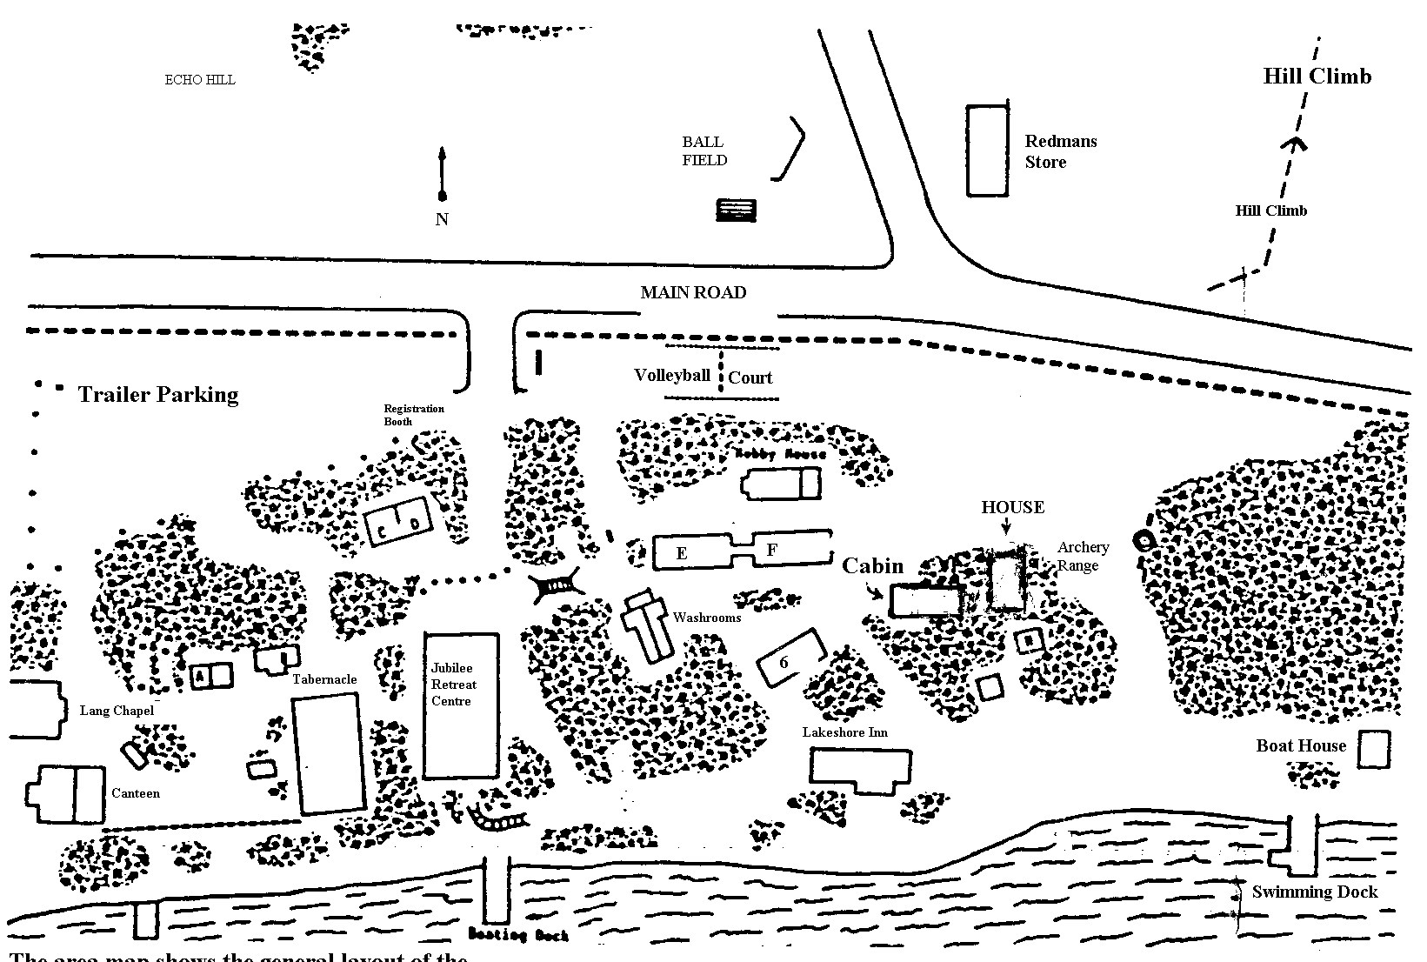

The area map shows the general layout of the camp buildings.

- Jubilee Retreat Center
  - Built in 1978
  - Fully modern winterized and air conditioned facility
  - Contemporary kitchen with 2 large commercial stoves, walk-in-cooler, 2 large freezers, commercial dishwasher, heated/waterless stainless steel food servers, cooking and serving equipment.
  - Dining Hall with a capacity of 300 people
  - Great view of Echo Lake and a large deck facing the lake
  - The Lower level has
· 14 individually electrically heated rooms
· Men's and Ladies Washrooms and Showers
· Fireside lounge for smaller group settings
- Tabernacle
  - Camp-meeting style chapel for general assemblies of up to 250 people.
  - The sides can be opened to provide for overflow or greater comfort in warm weather. - Unheated
- Lang Chapel
  - Former church building accommodates 60 - 80 people and is excellent for use as a classroom, seminar or devotional setting. - Unheated

- Canteen
    - Rental groups are responsible to secure and disburse their own stock
    - Equipped with Ice Cream Freezer
    - 2 Fridges which serve as Pop Coolers
    - Display shelves - A stock room
    - Half of the building provides sleeping accommodations for campers
    - Unheated • Hobby House
    - A large open room which can be utilized in various ways, especially in rainy weather - Adjacent to a large workshop with tables and benches for craft purposes.
- Cabins
    - Cabin 'B' is a lounge type cabin with a fireplace
    - Lakeshore Inn, by the lake, has 4 compartments. One of which has sofas and serves as a lounge or classroom. The other 3 compartments sleep 10-12 people each in single bunks.
    - Cabins 'E' and 'F' have been connected by a common entry, which contains two washrooms. There are a total of 14 separate rooms in these cabins
    - all unheated
- Former Managers cabin has a kitchenette and living room/Bedroom and may be used by house-guests who desire quiet, secluded accommodations.
- The remaining cabins have no particular features and vary in size and capacity
- Recreational Vehicle Locations
    - 11 sites with electrical and 'water only' hookups
    - 4 sites with are available with electrical hookups
    - On-site dumping station
- Washroom/Laundry Facility (unheated)
    - Men's and Ladies Washroom and Shower Rooms
    - Laundry room with washer and dryer
- Fire Pits
    - Designated areas for fireside gatherings and wiener roasts
    - Arrangements for firewood and the use of these areas are to be arranged with the Camp Manager.
-These areas and activities must be properly supervised to avoid the possibility of injury and any likelihood that the fires could spread beyond the designated area(s).

APPROXIMATE RECOMMENDED CAPACITY FOR CABINS
CAPACITY
CABIN 17 + Over 16 + Under JUBILEE RETREAT CENTRE

A - Left 3 4 CABIN Capacity

A - Right 3 4 1 8
2 8
D - Left 4 5 3 5 D - Centre 5 7 4 5
- - Right 4 5 5 5
6 5
- - 1 2 2 7 5
E - 2 2 2 8 5
E - 3 2 2 9 5 E - 4 2 2 10 5
E - 5 3 4 11 5
E - 6 3 4 12 5
E - 7 3 4 13 3
- - 8 3 4 14 3

- - 1 3 4 OVERFLOW AREAS
17 + Over | 16 + Under
7 | 9
7 | 10
8 | 11
F - 2 3 4
F - 3 3 4 B-Lounge
F - 4 3 4 Lakeshore Lounge
F - 5 3 4 Canteen Cabin
- - 6 3 4
MAXIMUM CAPACITY INCLUDING OVERFLOW
- - Left 4 5 218
G - Centre 2 3
- - Right 4 5

- - Counselor 2 2
H - Left 8 10 H - Centre 6 8
H - Right 8 10

JUBILEE RETREAT CENTRE (Lower Floor)
1 - Queen | 1 - Double |  | 1 - Double | 1 - Double |  | 1 - Double |  |  | 1 - Double | 1 - Double
1 - Double | 1 - Single |  | 1 - Single | 1 - Single |  | 1 - Single |  |  | 1 - Single | 1 - Bunk
1 - Single | 2 - Bunks |  | 2 - Bunks | 2 - Bunks |  | 2 - Bunks |  |  | 2 - Bunks
3 - Bunks  Room #2 | Room # 4 |  | Room # 6 | Room # 8 |  | Room # 10 |  |  | Room # 12 | Room # 14
Furnace |  | Men’s Washroom
Room  & Stairs |  | & Showers |  | MEGER LOUNGE
Ladies Washroom
& Showers
1 - Queen
1 - Double
 | 1 - Double |  | 1 - Double | 1 - Double |  | 1 - Double |  |  | 1 - Double | 1 - Double
1 - Single | 1 - Single |  | 1 - Single | 1 - Single |  | 1 - Single |  |  | 1 - Single | 1 - Bunk
3 - Bunks | 2 - Bunks |  | 2 - Bunks | 2 - Bunks |  | 2 - Bunks |  |  | 2 - Bunks
Room #1 | Room # 3 |  | Room # 5 | Room # 7 |  | Room # 9 |  |  | Room # 11 | Room # 13

N
O
R
T
H

JUBILEE RETREAT CENTRE (Upper Floor)
Storage  Room |  |  | Cooler | Stoves |  |  |  | DINING AREA
 |  |  |  | Sink & Counter
Entrance  & Stairs |  | Sinks, Counter & Dish Washer
 |  | DINING & MEETING A |  |  | REA
Telephone Room

N
O
R
T
H

KITCHEN AND DINING FACILITIES

Echo Lake Camp’s kitchen and dining room are supplied with equipment and dishes which make it possible to serve up to 150 people comfortable at one setting. The dining room can facilitate up to 300 with additional tables and benches in storage. Meals are served cafeteria or family style. Groups bringing their own food for cooking should ensure their cook has taken the Safe Food handling Course. Kitchen staff has access to:
- 2 large commercial stoves each with 2 ovens and a grill |  | - Walk-in cooler and 2 freezers
- 1-100 cup coffee percolator |  | - Large commercial rotating toaster
- Dishwasher and manual washing equipment |  | - Mixmaster
- Large pots, frying pans and roasters |  | - Cookie sheets, cake and muffin pans
- Mixing/serving bowls and platters of assorted sizes |  | - Dishes and cutlery for 150
- Salt and pepper shakers for the tables |  | - Tea towels, dish cloths
- Stainless steel hot food server |  | - Lots of counter space and sinks
- Washer and dryer for washing towels and aprons only. |  | - Cafeteria trays and tray carts

JUBILEE BUILDING
All campers are requested to observe the following for the effective maintenance of a pleasant, clean and safe environment.

- Remove all muddy footwear at the front door.

- Ask permission from Camp Manager before posting signs, pictures etc. o do not stick to walls, with tape or tacks.
o Use only the bulletin boards available.

- Report all defective equipment, i.e. toilets, sinks, windows etc. to the camp manager or his designate immediately.

- Only authorized staff is permitted in the Kitchen, Storage and Furnace room.

- Keep all doors and windows closed in summer, and drapes closed in the heat of the day, to facilitate operation of air conditioning.

- Clean up any obvious spills to avoid slips and injury.

- Use of the kitchen telephone for long distance calls is prohibited. Any calls made from phone booth are for emergencies only. No personal calls.

- Jubilee building is closed to all except occupants and authorized persons at 12:00 midnight.

- Do not use walls, shelving, doors & seats for unsightly damaging graffiti. This is a building unto the Lord and should be treated as such.

- Kindly treat the building and camp with care and consideration…we want to keep it a nice place for many people to come and enjoy God’s creation.

**Thank you for your consideration and co-operation**

PROGRAM AND ACTIVITY SUGGESTION

Baseball diamond, north of the road is available for baseball, soccer and other games needing an open grassy area and overnight outdoor camping. (Group must provide own equipment).

Beach volleyball court.

Playground for children.

Swimming and boating docks. To use, a group must provide own equipment and a qualified lifeguard.

Life Jackets

Canoes

Horseshoe pits

Ping pong tables in hobby house

Hiking Trail

Golf course nearby in Fort Qu’Appelle

Fish Hatchery in Fort Qu’Appelle

WHAT TO BRING

Sleeping bag and pillow
Bathing suit (in season) and other clothes appropriate for sports and games.
Appropriate clothing (for rainy, hot or cool weather)
Towels and toiletries

OPTIONAL
Camera
Binoculars
Musical Instruments
Sports equipment for archery, baseball, football, volleyball, tennis, hiking, ping pong, boating etc.

PLEASE LEAVE AT HOME...
Video games, personal music players
Fire arms
Alcoholic beverages
Illegal drugs or mind altering substances
Tobacco products
Pets

CLEAN UP

- Groups are expected to set up tables and chairs upon arrival.

- It is expected that a group will leave the camp as clean as or cleaner than when they arrived. Thus, prior to departure, arrange to have groups:

- Stack tables and chairs

- Vacuum all carpeted areas used, upstairs and down

- Clean and sanitize all washrooms

- Sweep floors and cabins used

- Place mattresses properly

- ALL garbage to be collected and put in large black garbage bags at back kitchen door.

- Clean kitchen sinks and counter tops

- Leave all dishes clean and in their proper places

- Sweep and wash Kitchen and Dinning room floors

The Camp Manager is available to give guidance where needed.

Emergency Procedures

- Each group should try to have their own nurse or fist aid person.

- Fort Qu’Appelle is 5KM away and has emergency services available at the All Nations Healing Hospital as well as the services of a doctor. Hospital phone number is 332-5611.

